2020-01-11 - Handout - Binary Trees

# Q1. All nodes distance K in a binary tree (LC#863)

Link: <https://leetcode.com/problems/all-nodes-distance-k-in-binary-tree>

We are given a binary tree (with root node root), a target node, and an integer value K. Return a list of the values of all nodes that have a distance K from the target node. The answer can be returned in any order.

|  |  |
| --- | --- |
|  | Input:  [3,5,1,6,2,0,8,null,null,7,4], target = 5, K = 2 Output: [7,4,1] |

# Q2. Recover Binary Search Tree (LC 99)

Link:<https://leetcode.com/problems/recover-binary-search-tree/>  
  
Two elements of a binary search tree (BST) are swapped by mistake. Recover the tree without changing its structure.

# 3.Maximum Binary Tree (LC654)

Link: <https://leetcode.com/problems/maximum-binary-tree/>

Given an integer array with no duplicates. A maximum tree building on this array is defined as follows:

1. The root is the maximum number in the array.
2. The left subtree is the maximum tree constructed from left part subarray divided by the maximum number.
3. The right subtree is the maximum tree constructed from right part subarray divided by the maximum number.

Construct the maximum tree by the given array and output the root node of this tree.

**Input:** [3,2,1,6,0,5]  
**Output:** return the tree root node representing the following tree:  
  
# Q4. Vertical Order Traversal of a Binary Tree (LC#987)

Link: <https://leetcode.com/problems/vertical-order-traversal-of-a-binary-tree/>

# Given a binary tree, return the *vertical order* traversal of its nodes values.

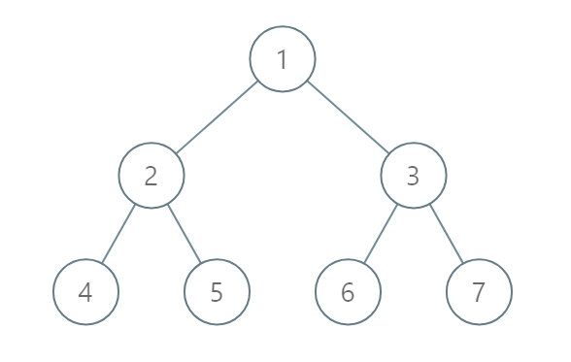

Input: [1,2,3,4,5,6,7]

Output: [[4],[2],[1,5,6],[3],[7]]

# 